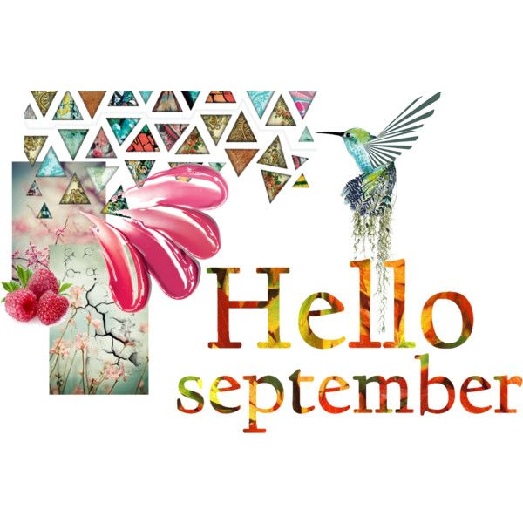
DATES TO REMEMBER:
SEPT. 3RD: LABOR DAY – * HOLIDAY *
SEPT. 6^{TH, 13TH, 20TH , 27TH} : SNEAKER-CISE IN NIMS @ 10 AM
SEPT. 10TH: MONTHLY CRAFT IN NIMS@ 10am
SEPT 20TH: BDAY CELEBRATION IN NIMS @ 1:45pm
Sept. 21st: PUPPET SHOW IN NIMS W/ MRS. SEEBER @ 10AM

