MAGNOLIA COMMUNITY SERVICES
NOVEMBER 2018 MEAL CALENDAR

SUNDAY | MONDAY | TUESDAY | WEDNESDAY | THURSDAY | FRIDAY | SATURDAY
 |  |  |  | 1  Corn & Crab Bisque OR  Chicken w/ Gravy  Rice  Green Beans  Salad  Oatmeal Pies | 2  Breaded Chicken  Breast OR Chicken  w/ Gravy on Bun  Mixed Veggies  Apple Slices | 3
4 | 5  Smothered Okra &  Tomatoes OR  Chicken w/ Gravy  Rice  California Blend  Salad/ Diced Pears | 6  Lima Beans w/  Sausage & Rice OR  Jambalaya  Capri Blend  Lemon Pie | 7 Orange Pork Chops OR Chicken w/ Gravy  Stir Fry Rice  Brussel Sprout  Salad/ Apple Cakes | 8  Shrimp Alfredo OR  Chicken w/ Gravy  Pasta  Cauliflower  Salad  Jello w/ Fruit | 9 Chicken Fried  Steak w/ Country  Gravy OR Chicken  w/ Brown Gravy  Mashed Potatoes  Buttered Peas  Sherbet | 10
11 | 12  Red Beans OR  Chili w/ Rice  Collard Greens  Salad  Yogurt w/ Fruit | 13  Meat Sauce OR  Chicken w/ Gravy  Pasta  Peas & Carrots  Chocolate Pudding | 14 BBQ Chicken  OR  Chicken w/ Gravy  Dirty Rice  Broccoli  Salad  Tropical Fruit | 15  Beef Stew OR  Chicken w/ Gravy  Chateau Blend  Salad  Apple Slices | 16  Chicken Nuggets  OR  Chicken w/ Gravy  Mac & Cheese  Mixed Veggies  Cookies | 17
18 | 19  White Beans OR  Chicken w/ Gravy  Rice  Green Beans  Salad/ Sherbet | 20  Tacos w/ Refried  Beans OR Chicken  w/ Gravy & Rice  Peas  Mandarin Oranges | 21  THANKSGIVING  LUNCH | 22 THANKSGIVING  HOLIDAY  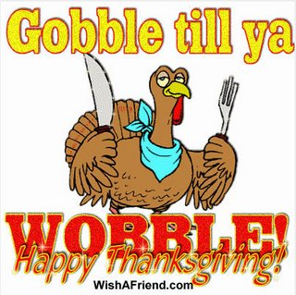 | 23  THANKSGIVING  HOLIDAY  CLOSED | 24
25 | 26 Beef Stir Fry OR  Chicken w/ Gravy  Rice  Cauliflower  Fig Bars | 27  Jambalaya OR  Chicken w/ Gravy  Rice  Winter Blend  Jello w/ Fruit | 28 Pork & Beans  w/ Sausage OR  Chicken w/ Gravy  Rice  Monterey Blend  Salad / Cookies | 29 BBQ Chicken  OR Tuna on Bun  Tater Tots  Salad  Apple Cakes | 30 Chicken &  Sausage Gumbo  OR Chicken w/  Gravy & Rice  Buttered Peas  Bread Pudding

