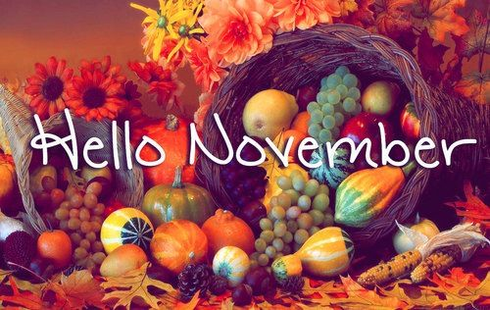
DATES TO REMEMBER:
NOV.15TH: NIMS THANKSGIVING CRAFT @ 10AM
& NOV.15TH: NIMS THANKSGIVING PARTY@1:30PM

NOV. 22ND –23RD :-THANKSGIVING HOLIDAYS OFF

NOV. 30TH: NIMS BDAY CELEBRATION @ 1:30PM

