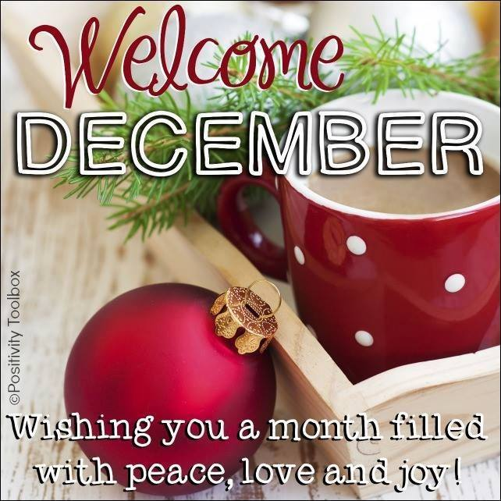
DATES TO REMEMBER:
DEC. 6TH:JEFF.GUILD ART XMAS CRAFT IN NIMS @ 1:00-2:30PM
DEC.7TH: XMAS PUPPET PERFORMANCE IN NIMS@ 10AM
DEC.7TH: XMAS BDAY CELEBRATION W/ SANTA IN NIMS @ 1:00-2:30PM
DEC.12TH: NIMS XMAS PARTY @ 1:30-2:30PM
DEC. 13TH: NIMS XMAS CRAFT @ 10AM
DEC.19TH: NIMS XMAS TALENT SHOW @ 12PM
DEC.21ST: NIMS SING A LONG WITH THE SCHMIDTS @ 10AM

* HOLIDAYS OFF*
DEC. 24TH, 25TH & 31ST & JAN. 1ST 2019**

