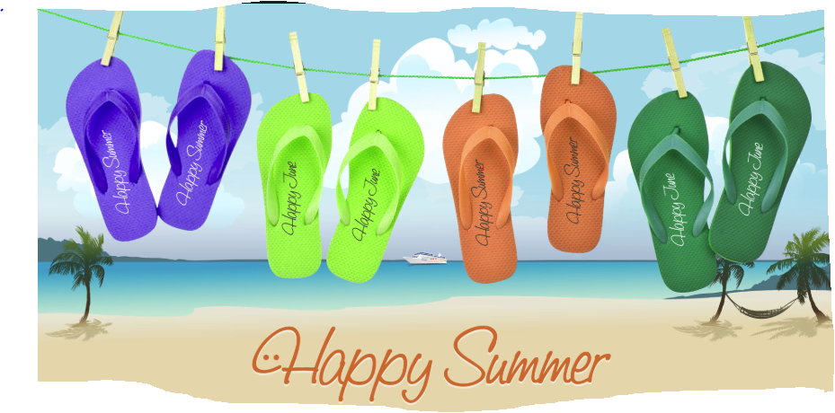
DATES TO REMEMBER:
JUNE 6TH: WATERDAY F1/C2 & F2 (1:00-2:00pm)
JUNE 7TH: NIMS CRAFT @ 10AM & NIMS SNOBALLS (12:00-1:30)
JUNE 11TH: WATERDAY E1 & E2 (10:15AM-11:15AM) & CAFÉ (1:00-2:00PM)
JUNE 14TH: WATERDAY B1 & B2, (10:15AM-11:15AM), H2 & CINTAS (1:00pm-2pm)
JUNE 18TH: WATERDAY D1, D2 (10:15AM-11:15AM) & G2 (1:00PM -2:00PM)
JUNE 19^{H}: WATERDAY H1, A1, & A2 (10:15AM-11:15AM) & JANITORIAL (1:00-2:00pm)
JUNE 21ST: WATERDAY DF (10:15AM-11:15AM) & G1 & S/C, (1:00pm -2pm) & NIMS SNOBALLS (12:00-1:30)
JUNE 26TH: NIMS TALENT SHOW
JUNE 27TH: WATERDAY C1 (10:15AM-11:15AM) & WH2 & WH3 (1:00pm-2:00pm)
JUNE 28: NIMS BDAY CELEBRATION@ 1:30PM

