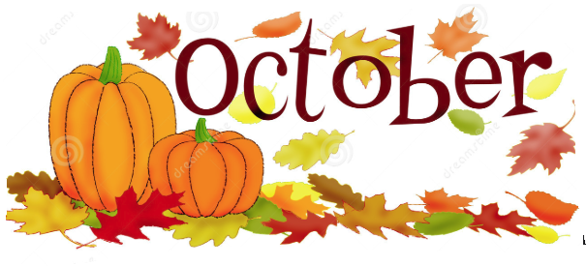
DATES TO REMEMBER:

OCT.4TH: NIMS CRAFT @ 10AM
OCT.28TH: LAKESHORE LADIES NIMS MUSICAL PRESENTATION @ 1PM
OCT. 29TH: NIMS HALLOWEEN SPECIAL STORYTIME @ 10 BY MRS. SCHMIDT
OCT. 31ST: NIMS HALLOWEEN COSTUME /BDAY PARTY @1:30PM

